Case 12-US-SD-Pine Ridge Indian Agency-Oglala Sioux-Minnekahta Limestone-Gorget
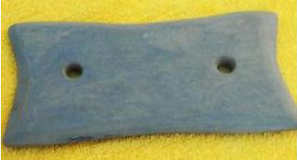
US-SD-Pine Ridge Indian Agency-Oglala Sioux-Minnekahta Limestone-Gorget

Case No.: 12
Accession Number:
Formal Label: US-SD-Pine Ridge Indian Agency-Oglala Sioux-Minnekahta Limestone-Gorget

Display Description:
Well-polished trade gorget. Minnekahta Limestone is extremely hard and dense.
LC Classification:
Date or Time Horizon: Trade Gorget, c 1880
Geographical Area: SW SD
Map: 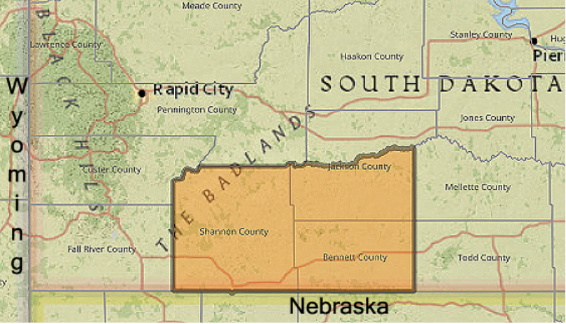
The official boundaries of the Pine Ridge Reservation in South Dakota.
GPS Coordinates:
Cultural Affiliation:
Medium: Minnekahta Limestone
Dimensions: L 7 in x Dia 2 in
Weight:
Provenance: Purchased from the Pine Ridge Indian Agency, 2011.
Condition:
Discussion:
References:
W. H. Raymond J. P. Gries R. U. King. STATUS OF MINERAL RESOURCE INFORMATION FOR THE PINE RIDGE INDIAN RESERVATION, SOUTH DAKOTA, Administrative Report BIA-12 1976.

